External Documentation

# Company Logo:



# Table of Contents:

Contents

Company Logo: 1

Table of Contents: 1

Description: 1

Nav Bar: 1

Colours: 1

Typography: 2

Wireframes: 2

Branding: 3

Description: Personal Portfolio website that contains information about contacting me, my projects, services that I offer, and other information about me.

Nav Bar:

# Colours:

|  |  |  |
| --- | --- | --- |
| Button Colours: #00728B | #00728B |  |
| Selected Page Colour: | #100873 |  |
| Hover Button Colour: | #574DD8 |  |
| Active Button Colour: | #2419B2 |  |
| Main/Side Content Background Colour: | #D3D3D3 |  |

# Typography:

All fonts are default family, color, and size.

# Wireframe:

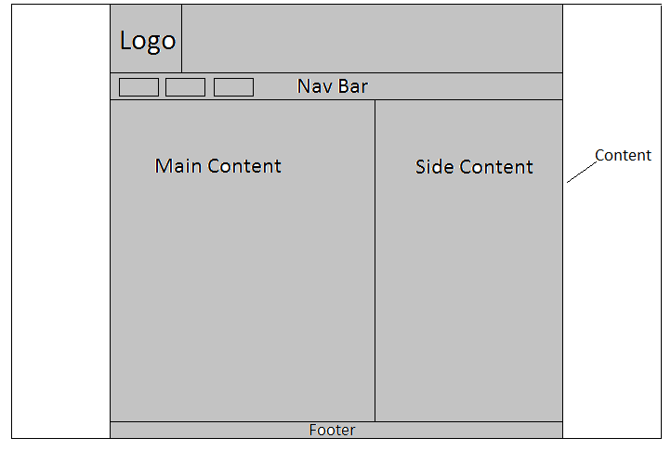

# 

# Branding:

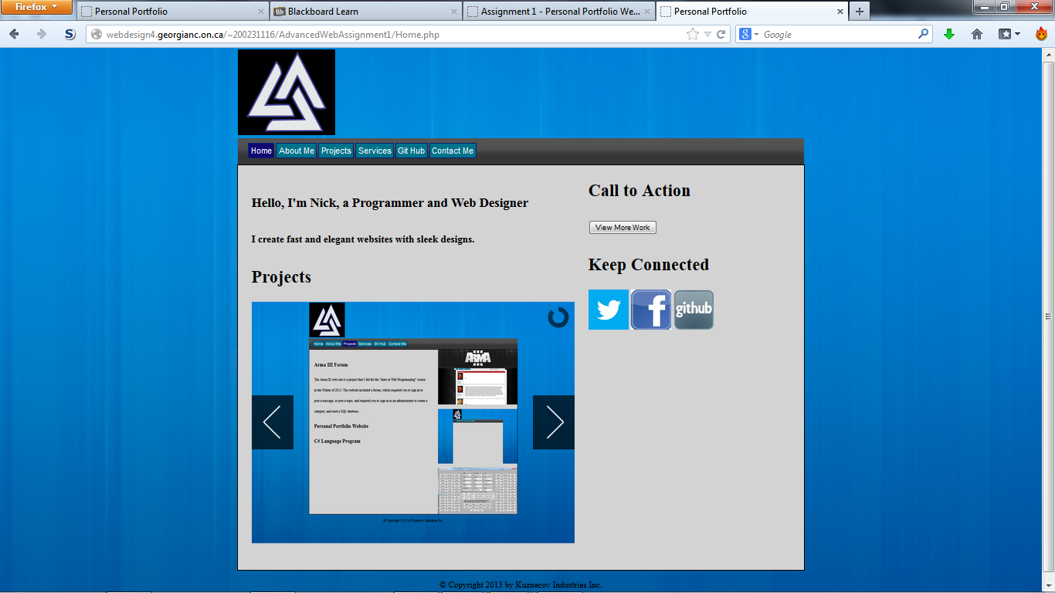

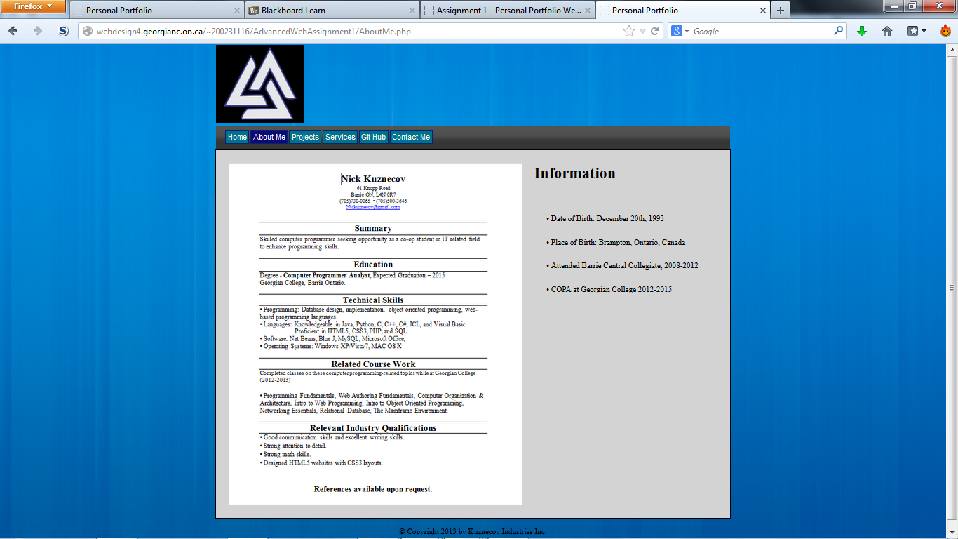

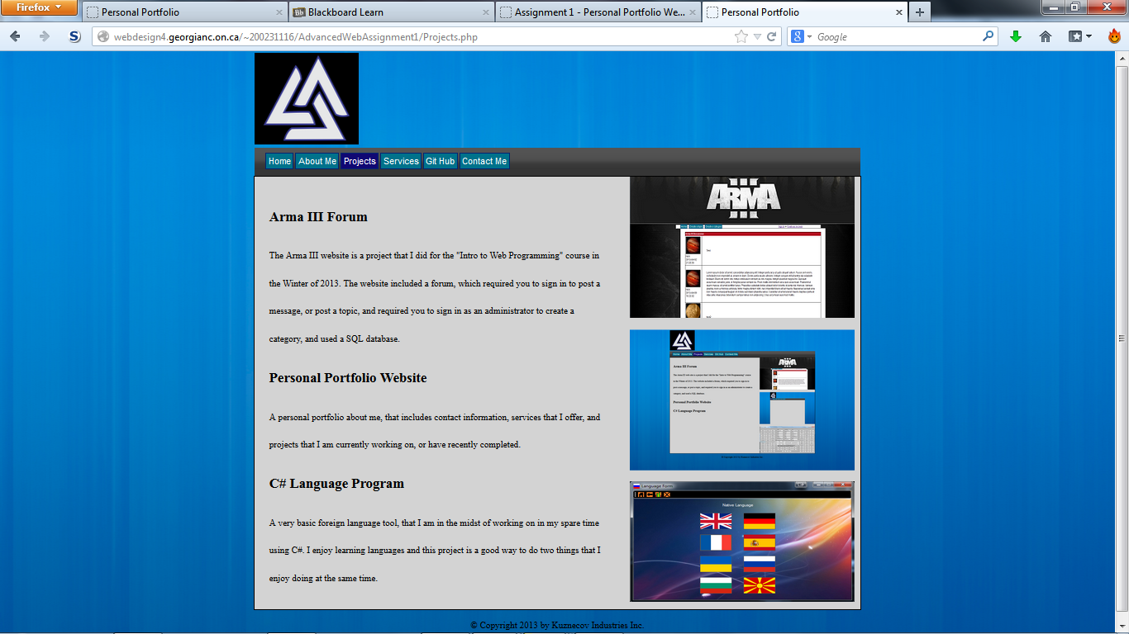

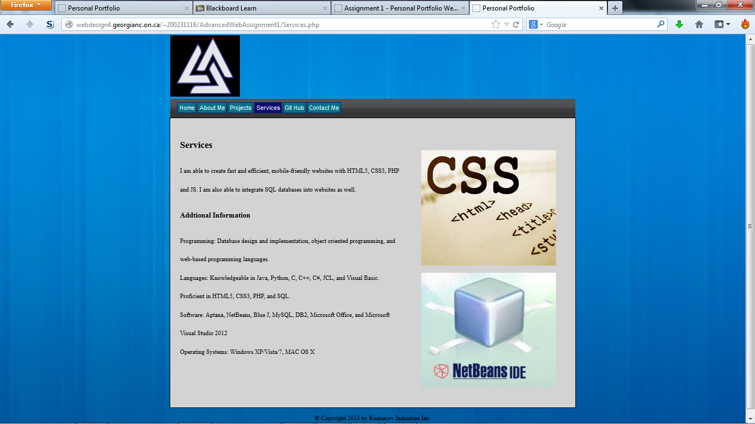

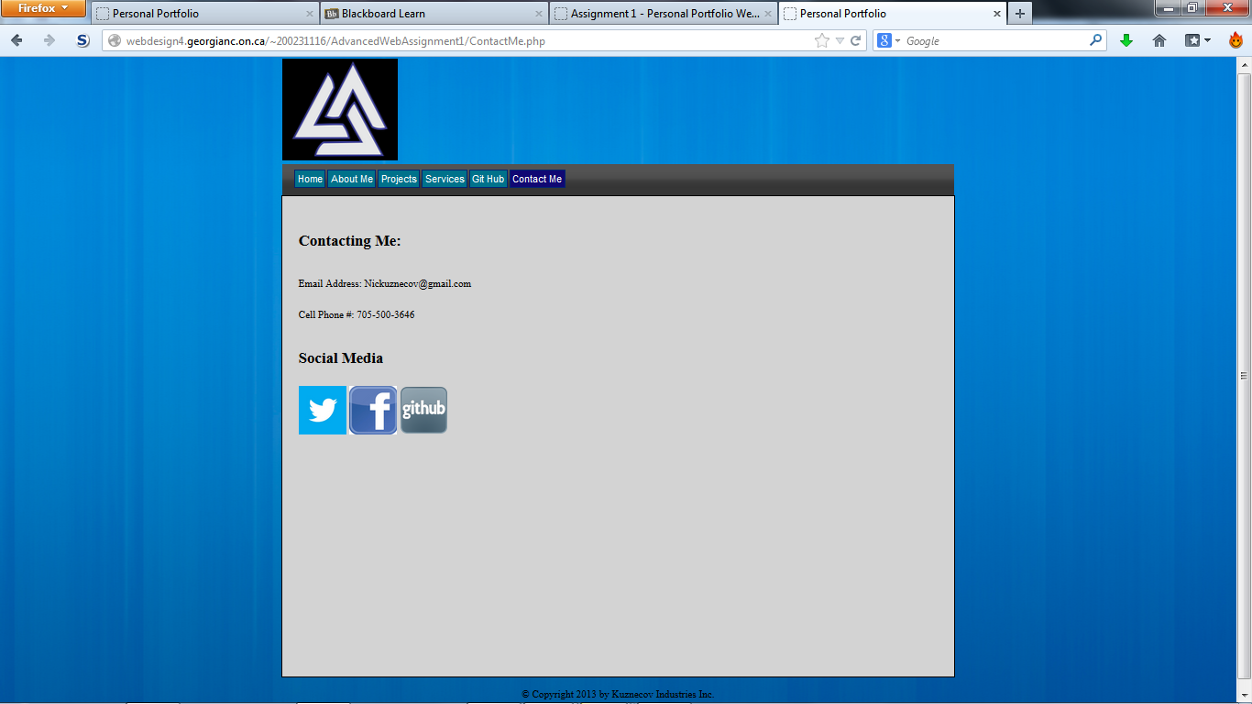

 Logo is black (#000000), light gray(#D3D3D3), and blue(2419B2)